To prepare effectively for your Functional English exam using the provided PDF notes, focus on these specific chapters. These are the ones that align directly with your teacher's syllabus:
1. Chapter 1: The Communication Process
- Why: This covers the foundations needed for "Making effective self and peer introductions."
- Focus on:
  - The Communication Model: Understanding Sender, Message, and Receiver.
  - Nonverbal Communication: This is crucial for how you present yourself during introductions (posture, eye contact).
2. Chapter 2: The Seven C's of Effective Communication
- Why: This is a core requirement of your syllabus.
- Focus on:
  - Courtesy & Consideration: This is where you learn "Requests versus commands" and how to use the "You-Attitude."
  - Clarity & Conciseness: Important for "Forming appropriate requests" and "Structuring instructions."
  - Correctness: Covers the "Writing mechanics" (Punctuation and Structure) mentioned at the end of your syllabus.
3. Chapter 5: The Process of Preparing Effective Business Messages – Focuses on planning, Direct vs. Indirect approaches, and audience analysis.
4. Chapter 6: The Appearance and Design of Business Messages – Covers letter parts, layouts (Full-Block/Modified), and punctuation styles.

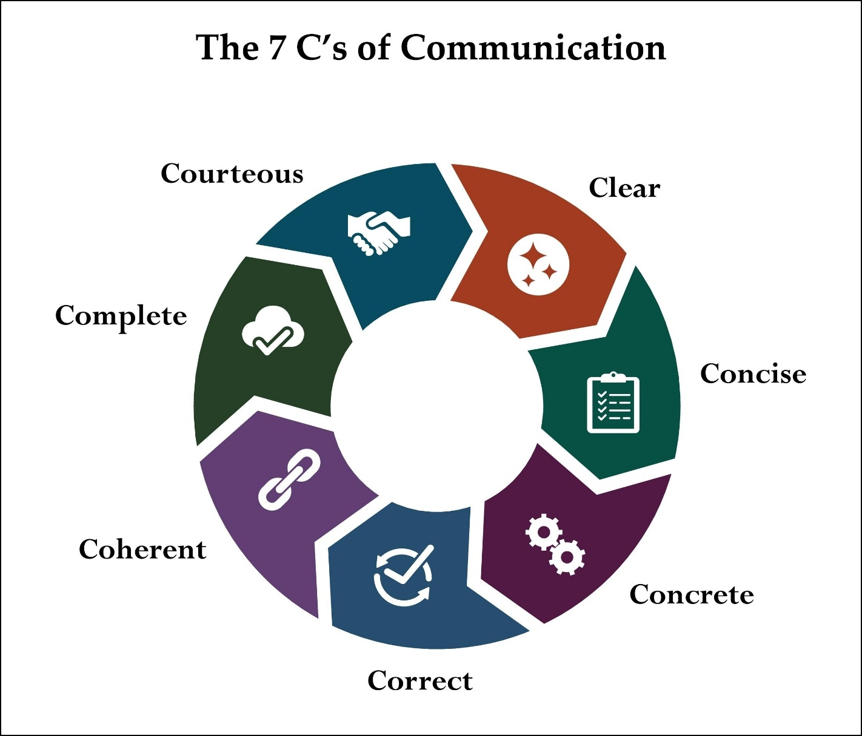
3. Chapter 7: Goodwill & Positive Messages
- Why: Directly addresses "Responding to enquiries," "Expressions of gratitude," and "Responding to a positive event."
- Focus on:
  - Thank-you notes: For the syllabus topic: "Writing a formal letter to say thanks to a teacher, parent, or friend."
  - Direct Request Pattern: For "Forming appropriate requests and enquiries."
4. Chapter 8: Negative/Bad-News Messages
- Why: This chapter is essential for the "Invitations" portion of your syllabus.
- Focus on:
  - Declining Invitations: How to say "no" politely.
  - Expressing Regrets: For the topic "Expressing regrets orally and in writing appropriately."
5. Chapter 10: Oral Presentations
- Why: Supports the oral components of your syllabus.
- Focus on:
  - Delivery Ways: Useful for "Demonstrating and practicing practical classroom language."
  - Opening a Speech: Helps with the "Self and peer introductions" requirement.

Important Reminder
The PDF does not cover "Directions/Maps" or "Story Narratives." For those, you must go back to the Word document links your friend sent you. Specifically, watch the videos for Lecture 11 (Summarizing Stories) and the video titled "Giving Directions" to fill those gaps.

To ensure you are fully prepared for your Functional English course, you should focus on the following specific video links from your teacher’s document. These cover the "Functional" and "Social" topics that are not present in the Business Communication PDF notes:
1. Social Interactions & Etiquette
The book PDF focuses on business, so you must use these links for personal and social language:
- Greeting and Gratitude: Essential for learning how to interact with friends and family.
  - Link: Social Interaction: Greeting and Gratitude
  - Link: Formal vs. Informal Greetings
- Inviting and Responding: While the book covers formal regrets, these videos explain the verbal social skills for invitations.
  - Link: HUM104 Lecture 04 - Inviting & Responding
2. Directions and Instructions
The PDF does not contain any information on maps or physical directions. You must prepare these links:
- Giving and Following Directions: Use these to learn how to read maps and reach destinations.
  - Link: How to Give Instructions and Follow Directions
- Daily Instructions: Learn the logic of carrying out and structuring step-by-step tasks.
  - Link: How to Carry Out Instructions
3. Narrative and Creative Skills
The syllabus requires re-telling stories and describing scenes, which are not business topics. Prepare these:
- Summarizing Stories: Essential for the "Re-telling and Summarizing Stories" syllabus requirement.
  - Link: Re-telling and Summarizing Stories
- Personal Narratives: Focus on sharing unique experiences as mentioned in your syllabus.
  - Link: Sharing Personal Narratives
4. Personal Expressions & Riddles
These specific functional language skills are unique to your teacher's document:
- Likes and Dislikes: Crucial for the social interaction part of your exam.
  - Link: Expressing Likes and Dislikes
- Future Plans: Learn how to talk about your intentions.
  - Link: Talking about Future Plans
- Riddles and Jokes: This is a specific syllabus requirement for "solving word puzzles" that is entirely missing from the PDF.
  - Link: Reading Riddles and Jokes
Summary Recommendation:
Use the PDF for the theory of the Seven C's, Writing Mechanics (Punctuation), and Formal Letter Writing. Use the YouTube links above for every topic involving Maps, Narratives, Stories, and Informal Conversations.

Mid term exam pattern:
Theory questions
Scenario based questions
Definitions
True false
Sentence correction
Active voice
Passive voice
Direct, indirect narration

